Lipotonix Plus Injections

Lipotonix injections are a type of lipotropic injection which includes amino acids and essential nutrients which have potential to assist in fat burning. These amino acids and nutrients gear up the metabolism which leads to using more energy- hence the fat burning. In most cases, Lipotonix injections are used in conjunction with other dietary regimens.

Lipotropic compounds work by encouraging your body to release fat. Lipotropic injections deliver the fat releasing action of lipotropic compounds directly into areas of your body that stubbornly hold onto fat molecules. Once lipotropic injections freed the fat from fat cells, the powerful compounds help your body convert that fat into instant fuel.
Lipotropics work by increasing production of lecithin in your liver. Lecithin emulsifies, or breaks down fat into smaller molecules known as fatty acids. While your body tends to store large fat molecules and fat cells for later use, it prefers to use the smaller fatty acid molecules immediately as instant energy. As an added bonus, emulsification allows fat to mix with water to make it easier for the body to transport fat away from your tummy, thighs, and butt.

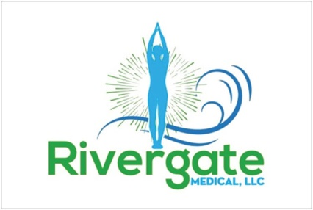

These lipotropic nutrients that help break down fat during that metabolic process include methionine, choline, and inositol. These nutrients promote the exportation and burning of fat from the liver for extra energy, thereby promoting liver health. Without lipotropics such as choline and inositol, fat and bile can become trapped in the liver, causing severe problems such as cirrhosis in the blockage of proper fat metabolism.
Choline is similar to B complex vitamins. Doctors prescribe choline to treat liver disease because of its fat burning abilities. Choline is also effective for the treatment of depression, memory loss, dementia, and Alzheimer’s disease, so lipotropic injections may even make you feel more relaxed and serene.
Choline is even more powerful when combined with another lipotropic compound, inositol, sometimes known as vitamin B 8. Inositol prevents fatty build up in your liver and an your heart, and helps or body convert the food you eat into energy. Together, the choline and inositol in lipotropic injections help the liver shuttle fat more efficiently. Like choline, doctors sometimes prescribe inositol for mood disorders so you may feel calm and relaxed.
Methionine assists in the breakdown of fats and aids in a fish indigestion. In addition to its fat burning properties, methionine is also an excellent antioxidant. Finally, at your body needs methionine to produce monohydrate, and essential compound for energy production and muscle building.
What are Lipotropic Compounds?
Lipotonix injections contain the following ingredients:
- B1
- B2
- B3
- B6
- B12 (hydrox)
- Methionine
- Inositol
- Choline
- L-carnitine
- Chromium

